**TRANSIT GATEWAY – 4 DIFFERENT REGIONS**

**Created VPC-1 in N. Virginia region.**

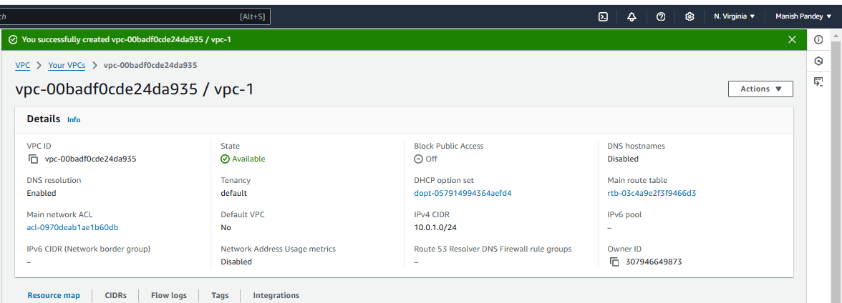

Created vpc-1-subnet for VPC-1

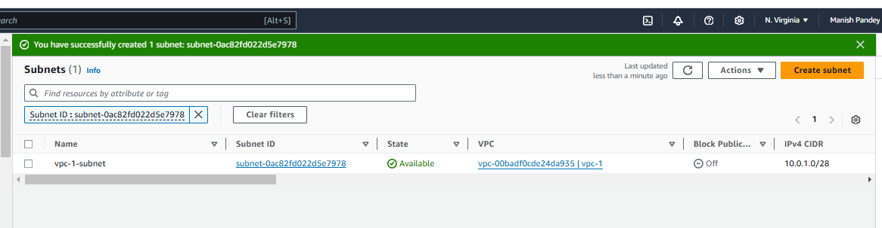

Created IG-1 for VPC-1

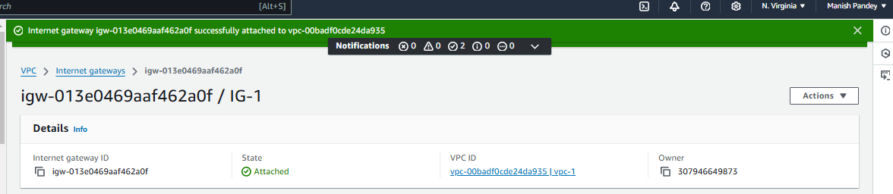

Also update route for IG-1 in Route Table – VPC -1

**Created VPC-2 in Ohio region**

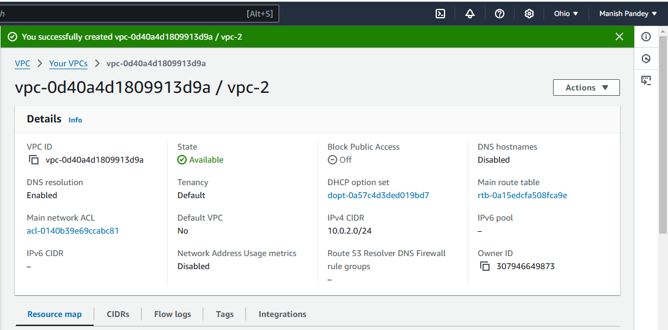

Created vpc-2-subnet for VPC-2

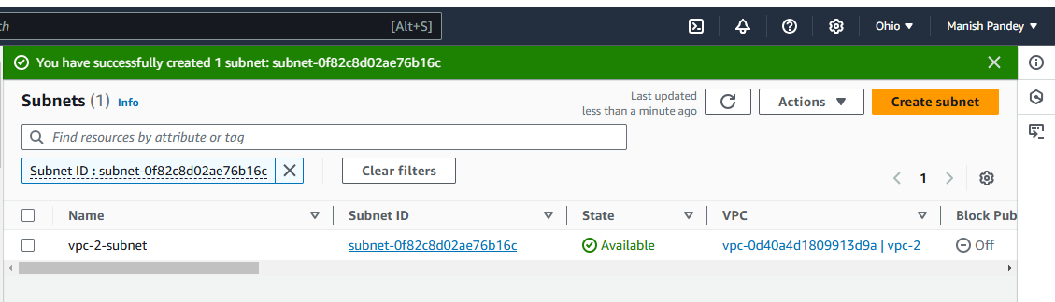

Created IG-2 for VPC-2

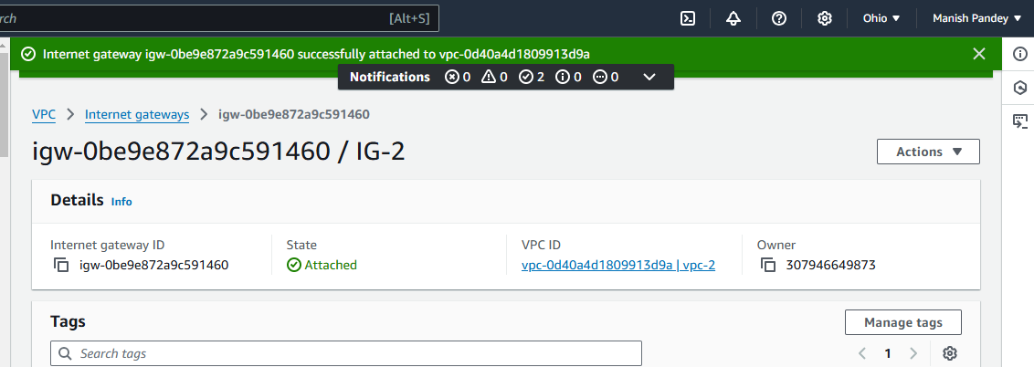

Also update route for IG-2 in Route Table – VPC -2

**Created VPC-3 in N. California Region**

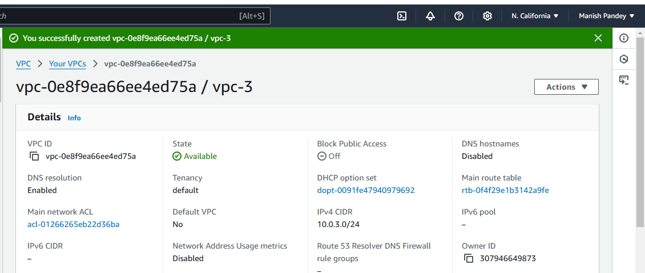

Created vpc-3-subnet for VPC-3

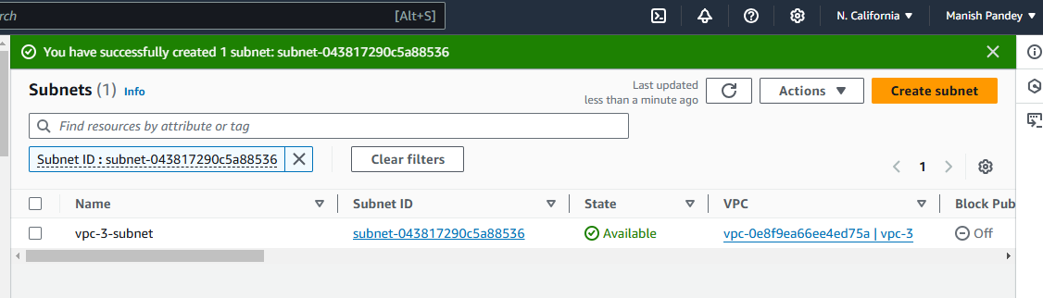

Created IG-3 for VPC-3

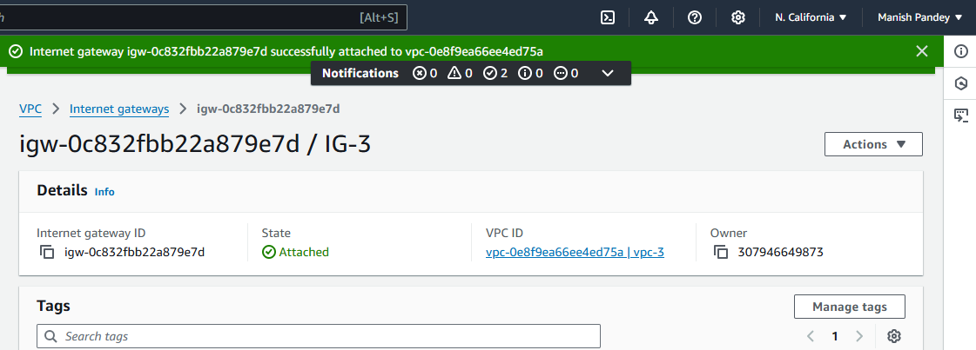

Also update route for IG-3 in Route Table – VPC-3

**Created vpc-4 in Oregon Region**

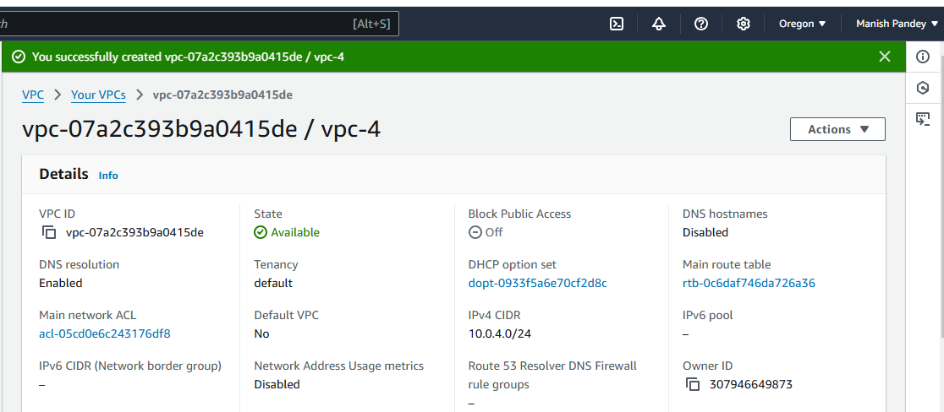

Created vpc-4-subnet for VPC-4

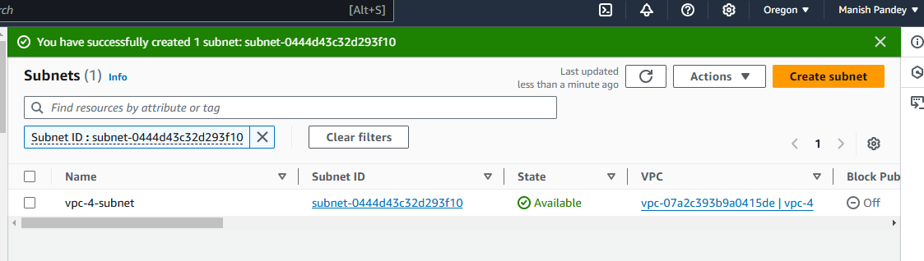

Created IG-4 for VPC-4

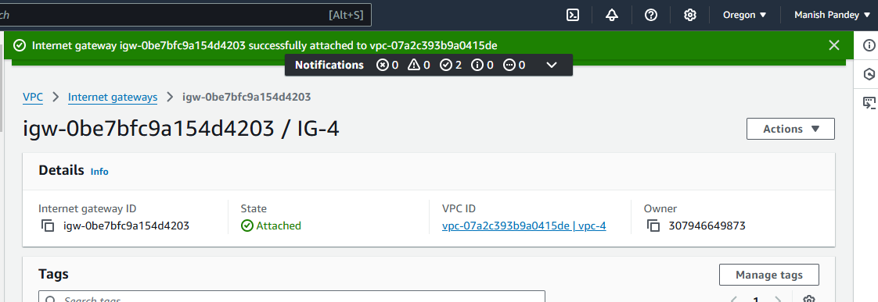

Also update route for IG-4 in Route Table – VPC -4

TGA1

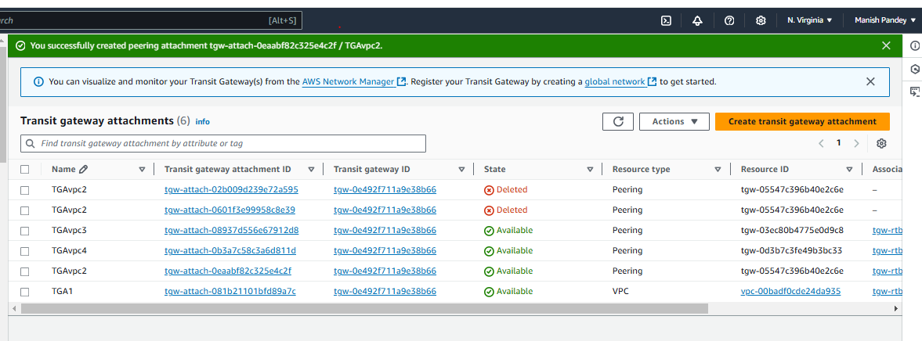

TGA2

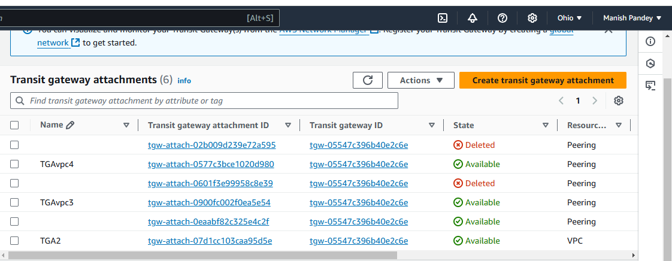

TGA3

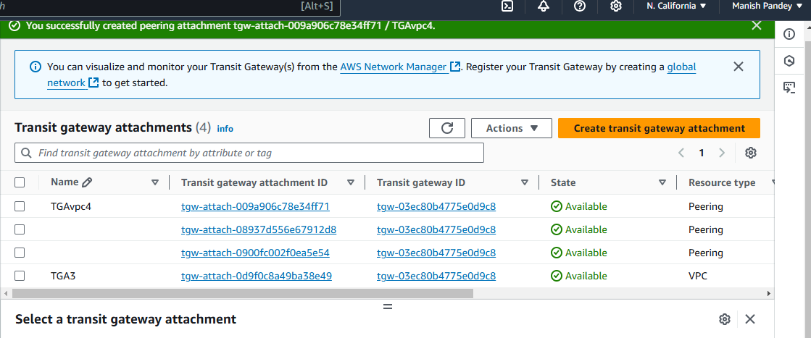

TGA4

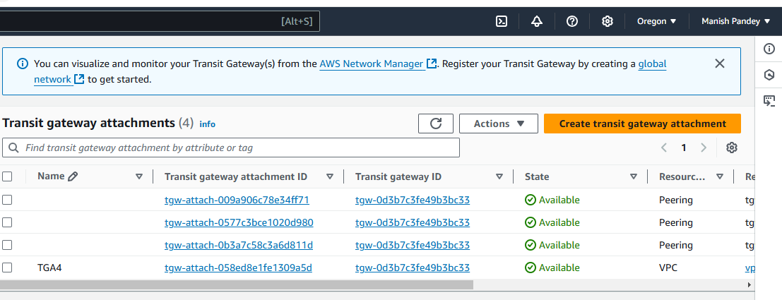

* Update VPC CIDRs of all vpcs in every Transit Gateway Route Tables by creating static routes for all VPC CIDRs.
* Update VPC Route Tables with CIDRs of all VPCs.
* Launch one instance in each region.
* Set traffic in security groups.

